**INDEXES Lab**

**Conor Griffin X00111602**

There are different type of Indexes that are supported by the Oracle 11G DBMS e.g. Primary Key Indexes, unique and non-unique indexes. Let us explore some of them.

**EXERCISE**

When you CREATE or ALTER a table with a PRIMARY KEY and/or a UNIQUE KEY constraints, indexes are automatically created. However, you can manually create the indexes giving the advantage of giving them appropriate names

1. Create the following tables and insert some rows into them. The data should be entered in lowercase. Examine the USER_INDEXES , USER_IND_COLUMNS and USER_CONSTRAINTS views. How are the constraints named? How are the indexes named? What type of indexes have been created on the mydept and myEmp table? Were you expecting more?

**CREATE TABLE myDept**

**(**

**dept_id VARCHAR2(9) PRIMARY KEY,**

**dept_name VARCHAR2(30) NOT NULL UNIQUE**

**);**

**CREATE TABLE myEmp(**

**staff_id NUMBER(9) PRIMARY KEY,**

**ppsn VARCHAR2(12) NOT NULL UNIQUE,**

**last_name VARCHAR2(25) NOT NULL,**

**first_name VARCHAR2(25) NOT NULL,**

**dept_id VARCHAR2(9),**

**CONSTRAINT fk_mydept_dept_id FOREIGN KEY (dept_id) REFERENCES mydept(dept_id)**

**);**

**INSERT INTO myDept VALUES ('1', 'Databases');**

**INSERT INTO myDept VALUES ('2', 'Software Development');**

**INSERT INTO myDept VALUES ('3', 'ADS');**

**INSERT INTO myEmp VALUES(1, '122485C', 'Griffin', 'Conor', '5');**

**INSERT INTO myEmp VALUES(2, '968499H', 'Keogh', 'Ruairi', '3');**

**INSERT INTO myEmp VALUES(3, '874432B', 'Healy', 'Lee', '2');**

**SELECT * FROM USER_INDEXES;**

**- Name based on the fact it shows you the index type. All the index types are ‘Normal’ which is the default b-tree index.**

**SELECT * FROM USER_IND_COLUMNS;**

**- Name based on the fact it shows individual columns**

**SELECT * FROM USER_CONSTRAINTS;**

**- Name based on the fact it shows the constraint type**

**EXERCISE**

1. You should notice that an index for the Foreign Key constraint does not exist. If there are lots of queries like

**SELECT last_name, first_name, dept_name**

**FROM mydept md, myemp me  
WHERE md.dept_id=me.dept_id**

you will end up with full table scans. Create an appropriate index for the foreign key using the CREATE INDEX command. Check USER_INDEXES view to see they index definition

**CREATE INDEX fk_index ON myEmp (dept_id);**

1. Drop myEmp and myDept tables. Check the indexes data dictionary view to see do the indexes exist.

**DROP TABLE myEmp;**

**DROP TABLE myDept;**

**SELECT * FROM USER_INDEXES;**

**The indexes that we could see before from the data dictionary are now gone.**

1. You can explicitly name a PRIMARY KEY index whilst creating a table. Review the syntax and re-create the myDept table as follows. Then query USER_CONSTRAINTS, USER_IND_COLUMNS and USER_INDEXES for this table. What do you notice?

**CREATE TABLE myDept**

**(**

**dept_id VARCHAR2(9) PRIMARY KEY USING**

**INDEX (CREATE UNIQUE INDEX dept_id_pk_idx**

**ON mydept(dept_id)),**

**dept_name VARCHAR2(30) NOT NULL UNIQUE USING**

**INDEX (CREATE UNIQUE INDEX dept_name_idx**

**ON mydept(dept_name))**

**);**

**After querying user_constraints, user_ind_columns and user_indexes I noticed that the indexes created where manually created with the table instead of individually.**

1. Now recreate table myEmp. Make sure to explicitly name the indexes for the primary key AND the unique key. **Note** add the Foreign Key Index after you have created the table. Check the USER_CONSTRAINTS, USER_IND_COLUMNS and USER_INDEXES for this table to see what has been created in the data dictionary.

**CREATE TABLE myEmp(**

**staff_id NUMBER(9) PRIMARY KEY USING**

**INDEX (CREATE UNIQUE INDEX staff_id_pk_idx**

**ON myemp(staff_id)),**

**ppsn VARCHAR2(12) NOT NULL UNIQUE USING**

**INDEX (CREATE UNIQUE INDEX ppsn_idx**

**ON myemp(ppsn)),**

**last_name VARCHAR2(25) NOT NULL,**

**first_name VARCHAR2(25) NOT NULL,**

**dept_id VARCHAR2(9),**

**CONSTRAINT fk_mydept_dept_id FOREIGN KEY (dept_id) REFERENCES mydept(dept_id)**

**);**

1. Execute the following SQL statements individually. Explain the reason for the error.

**CREATE TABLE test (col1 NUMBER);**

**CREATE INDEX test_col1_i ON test(col1);**

**DROP TABLE test;**

**DROP INDEX test_col1_i;**

**The Index is already dropped when you dropped the table before-hand hence why you get the error ‘specified index does not exist’**

1. Now execute these statements individually. What do you concur?

**CREATE TABLE test (col1 NUMBER);**

**CREATE INDEX test_col1_i ON test(col1);**

**DROP INDEX test_col1_i;**

**DROP TABLE test;**

**The index was dropped before the table was dropped which is allowed, so there was no errors generated as it is allowed to be dropped in this order.**

**EXERCISE**:

Review the ERD and accompanying notes below. Accordingly, create the following tables:

1. **ittcourse** that has the following columns course_id (primary key) , course_name, course_description. course _name is mandatory.

**CREATE TABLE ittcourse (**

**course_id NUMBER(9) PRIMARY KEY USING**

**INDEX (CREATE UNIQUE INDEX ittcourse_id_pk_idx**

**ON ittcourse(course_id)),**

**course_name VARCHAR2(40) NOT NULL,**

**course_description VARCHAR2(40)**

**);**

1. **ittstudent** that has columns stud_id (primary key),ppsn (unique key), firstname, lastname, phone. All columns are mandatory.

**CREATE TABLE ittstudent (**

**stud_id NUMBER(9) PRIMARY KEY USING**

**INDEX (CREATE UNIQUE INDEX student_id_pk_idx**

**ON ittstudent(stud_id)),**

**ppsn VARCHAR2(12) NOT NULL UNIQUE USING**

**INDEX (CREATE UNIQUE INDEX ppsn_idx**

**ON ittstudent(ppsn)),**

**first_name VARCHAR2(25) NOT NULL,**

**last_name VARCHAR2(25) NOT NULL,**

**phone VARCHAR2(15) NOT NULL**

**);**

1. **ittstudentCourse** table is an table containing course_id and stud_id (as a composite primary key) and enrolment_date, completion_date

**CREATE TABLE ittstudentcourse (**

**course_id NUMBER(9),**

**stud_id NUMBER(9),**

**enrolment_date VARCHAR2(20),**

**completion_date VARCHAR2(20),**

**CONSTRAINT pk_ittstudentcourse_con PRIMARY KEY (course_id, stud_id)**

**);**

ITTCourse

ITTStudentCourse

ITTStudent

**Notes**

Indexes must be explicitly named as follows:

* The primary key **index** for ittcourse must be called ittcourse_id_pk_idx
* The primary key **index** for ittstudent must be called student_id_pk_idx
* The primary key **index** for ittstudentcourse must be called ittstudcourse_ids_comppk_idx and the primary key constraint must be called pk_ittstudentcourse_con. **Note** you need to create the index when you are creating the Table constraint
* After creating the ITTStudentsCourse table add indexes for the 2 foreign key constraints

**CREATE INDEX fk_course_id_index ON ittstudentcourse (course_id);**

**CREATE INDEX fk_stud_id_index ON ittstudentcourse (stud_id);**

**Exercise**

1. Create a nonunique index on course_name on the ittcourse table. Then DROP the index!

**CREATE INDEX course_name_idx ON ittcourse(course_name);**

**DROP INDEX course_name_idx;**

1. Insert 5 rows each into course and student tables respectively and “register” a number of students on the courses.

**INSERT INTO ittcourse VALUES (1, 'Law' , 'Law & Order');**

**INSERT INTO ittcourse VALUES (2, 'History', 'The Secret To History');**

**INSERT INTO ittcourse VALUES (3, 'Computer Science', 'Computing');**

**INSERT INTO ittcourse VALUES (4, 'Creative Digital Media', 'Digital Media');**

**INSERT INTO ittcourse VALUES (5, 'Business', 'Rule the world');**

**INSERT INTO ittstudent VALUES (1, '34226Y', 'Conor', 'Griffin', '0853345678');**

**INSERT INTO ittstudent VALUES (2, '88712T', 'Damien', 'Ward', '0838798877');**

**INSERT INTO ittstudent VALUES (3, '23455W', 'Graham', 'Lalor', '0879822123');**

**INSERT INTO ittstudent VALUES (4, '88997S', 'Lee', 'Healy', '0868765567');**

**INSERT INTO ittstudent VALUES (5, '90554R', 'Lucy', 'Bell', '0834434654');**

1. Let us execute a few queries and see what index was used by examining the Execution plan as follows (**note** change the values to suit your data):

**set autotrace on explain**

**select * from ittcourse**

**where course_name='networking';**

**set autotrace on explain**

**select * from ittcourse**

**where course_name='Computer Science';**

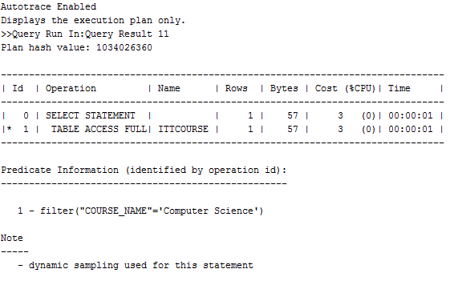

The execution Plan can be examined under “script output” tab beside the query result. You should have noticed for the above execution plan that NO index was used. This is expected as we have not created an index on course_name. The ittcourse table was scanned using the predicate filter( "COURSE_NAME"='networking')

Examine the Execution Plans for the queries below.Capture the Execution Plan Output. Interpret it in the context of whether an index was used or not; how the index was accessed; how the table was accessed.

**set autotrace on explain**

**select course_name from ittcourse**

**where course_id = 999;**

**set autotrace on explain**

**select course_name from ittcourse**

**where course_id = 5;**

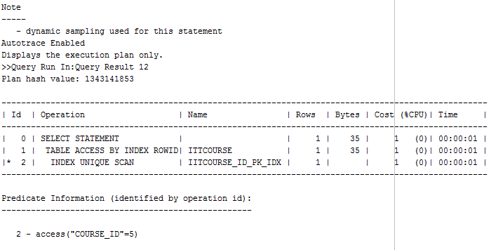

**set autotrace on explain**

**select * from ittcourse**

**where course_id = 999 and course_name='databases';**

**set autotrace on explain**

**select * from ittcourse**

**where course_id = 5 and course_name='Creative Digital Media';**

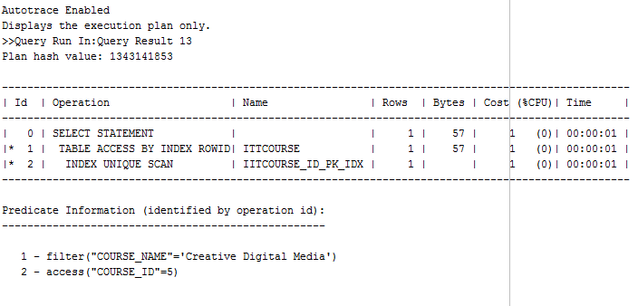

**Index was used as it uses course_id = 5 as an index rowed to access**

**[note to turn off autotrace SET AUTOTRACE OFF;]**

**set autotrace off;**

1. Examine the execution plan for the query below , identifying whether an index was used of not. What was the name of the index if an index was used? If no Index was used, create an appropriate one with a CREATE INDEX stu_last_firstname_indx. Rerun your query what do you notice?

**set autotrace on explain**

**SELECT firstname,lastname**

**FROM ittstudent**

**WHERE lastname='smith'**

**AND firstname='james';**

**set autotrace on explain**

**SELECT first_name, last_name**

**FROM ittstudent**

**WHERE last_name='Griffin'**

**AND first_name='Conor';**

**NO INDEX WAS USED IN THIS QUERY**

**CREATE INDEX stu_last_firstname_indx ON ittstudent(last_name, first_name);**

1. Run the query below. Examine the execution plan. The Cost Based Optimizer CBO execution plan can be overridden by using a hint **/*+ index(i stu_last_firstname_indx) */ .** We are forcing the Cost Based Optimizer ( CBO) to use the index.

Note: change the command to use the index you created.

**set autotrace on explain**

**SELECT /*+ index(ittstudent stu_last_firstname_indx) */ firstname,lastname,ppsn**

**FROM ittstudent**

**WHERE lastname='smith';**

**Remove the index you created in 14).**

**set autotrace on explain**

**SELECT /*+ index(ittstudent stu_last_firstname_indx)*/ first_name,last_name,ppsn**

**FROM ittstudent**

**WHERE last_name='Healy';**

